CMP9137M - Machine Learning Assignment 1 – “**Detection of Pneumonia in Medical Images**”.

DUE: 19/05/2022

Task 1:

You are required to use Machine Learning techniques to tackle the problem of “**Detection of Pneumonia in Medical Images**”.

All Machine Learning Models:

<https://towardsdatascience.com/all-machine-learning-models-explained-in-6-minutes-9fe30ff6776a>

Understanding Classification:

<https://towardsdatascience.com/machine-learning-classifiers-a5cc4e1b0623>

Different types of classifiers

<https://www.greycampus.com/opencampus/machine-learning/different-types-of-classifiers>

Paper on Pneumonia detection to discuss

<https://journals.plos.org/plosone/article?id=10.1371/journal.pone.0256630>

Well explained example of detecting pneumonia in x-rays with CNN, DenseNet

<https://towardsdatascience.com/deep-learning-for-detecting-pneumonia-from-x-ray-images-fc9a3d9fdba8>

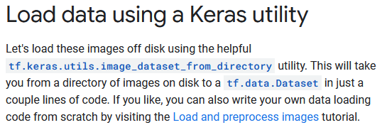

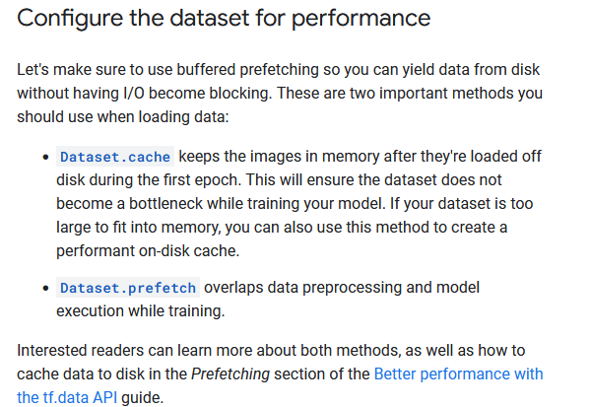

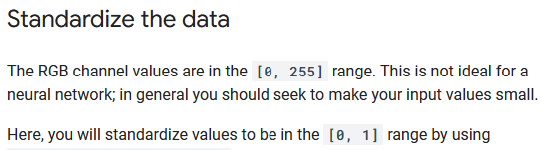

<https://www.tensorflow.org/tutorials/images/classification>

It's good practice to use a validation split when developing your model. Let's use 80% of the images for training, and 20% for validation.

To verify that a model is not over-fitted, k-fold cross validation needs to be used

Task 2:

You are required to use Machine Learning to tackle the problem of “**Game Learning**”.